Project Report on

**Unison of Quality Function Deployment (QFD) and User’s Preference Rating for Selection Process of Fourth Party Logistics (4 PL)**

Submitted by:

Aman Mansuri Prabhat Pavecha Vini Sehgal

(13117007) (13119042) (13119056)

Under the guidance of:

Dr. Akshay Dvivedi

Assistant Professor,

Department of Mechanical

and Industrial Engineering,

IIT Roorkee



**DEPARTMENT OF MECHANICAL AND INDUSTRIAL ENGINEERING**

**INDIAN INSTITUTE OF TECHNOLOGY ROORKEE**

**CERTIFICATE**

This is to certify that the report submitted by **Aman Mansuri**, **Prabhat Pavecha** and **Vini Sehgal** on “**Unison of Quality Function Deployment (QFD) and User’s Preference Rating for Selection Process of Fourth Party Logistics (4 PL)**” is an authentic record of the project work which they have satisfactorily completed under my supervision. This report is in partial fulfilment of the B.Tech Project (MIN-400).

.................................

Dr. Akshay Dvivedi

Assistant Professor,

Department of Mechanical

and Industrial Engineering,

IIT Roorkee

DATE: …………………

**DECLARATION BY THE CANDIDATES**

We hereby declare that this written submission is an authentic record of our own work from the period

August 2016 till May 2017 under the guidance of Dr. Akshay Dvivedi, Assistant Professor,

Department of Mechanical and Industrial Engineering, Indian Institute of Technology Roorkee.

The matter embodied in this report to the best of our knowledge has never been presented elsewhere for a degree.

DATE: …………………..

……………………… ……………………… ………………………

Aman Mansuri Prabhat Pavecha Vini Sehgal

(13117007) (13119042) (13119056)

**ACKNOWLEDGEMENT**

We take this opportunity to express our deepest gratitude to all those who encouraged and supported us to complete this project.

We can’t emphasise how grateful we are to our mentor, Dr. Akshay Dvivedi, who in spite of being extraordinarily busy with his duties, took time out to hear and guide us and gave us immense confidence at every stage of our project.

We express our deepest gratitude to our Head of Department, Dr. Dinesh Kumar, for giving us the platform to pursue our ideas. It was a great learning experience that enabled us to use our engineering concepts to make a contribution to the industry.

We also wish to thank our professors, Dr. A.K. Sharma, Dr. P.K. Jha and Dr. D.B. Karunakar for giving us critical feedback that helped us explore different dimensions of our project.

It is our radiant sentiment to place on record our best regards, deepest sense of gratitude to all the industry experts from Flipkart, Amazon India, Snapdeal, Ajio and Ebay India for providing us with necessary information that were very useful to complete our project. Lastly, we wish to thank our parents and friends for their constant support that helped us to deliver to the best of our abilities.

We perceive this opportunity as a big milestone in our career development. We will strive to use the gained skills and knowledge in the best possible way, and will continue to work on their improvement, in order to attain our desired career objectives.

**ABSTRACT**

There is a boom and a rapid growth of E-commerce in India. E-commerce companies are competing with each other for market share which is worth billions of dollars. With this type of competitive environment and growth rate, a good fit of strategic suppliers could lead to the success of a company. Having a robust supply chain would certainly give a company a competitive edge over its competitors. Supply Chain is one of those areas where there has been a lot of innovation and companies find it difficult to find a partner in this field who can serve them best.

In this project, we have developed a tool that will help E-commerce companies to select a Fourth Party Logistics partner according to their needs.The tool developed has inculcated the needs of some E-commerce companies and also converted the incomplete information of user needs (WHATs) into quantitative form using User’s Preference Rating. Responses were taken from industry experts working in the field of Supply Chain and Operations from various E-commerce companies like Flipkart, Amazon India, Snapdeal, AJIO and Ebay India. From the responses collected, Preference Graphs of user needs was drawn for each company and the normalised weights of the user needs were then calculated.

The tool developed incorporates Quality Function Deployment and gives the importance rating of each technical descriptor (HOWs) with the help of House of Quality principles. There is a provision for assessing various 4 PL service providers on these technical descriptors and hence, determining the most suitable one as required by the user/company.

**CONTENTS**

Certificate

Declaration by the candidates

Acknowledgement

Abstract

Contents

List of Tables

List of Figures

Introduction

Motivation

Objective

Scope

Timeline

Literature Review

Introduction to Logistics

Introduction to 4 PL

E-commerce logistics

What is QFD

What is User Preference Rating

Methodology

Determination of WHATs (and what we inferred from it)

Determination of HOWs

Calculation of weights of WHATs (procedure and final weights, Survey, Survey result)

Development of Relationship Matrix

Results(Guidelines)

Conclusion

References

**List of Tables**

**List of Figures**

**1. Introduction**

**1.1 Motivation**

As the students of Mechanical and Industrial Engineering Dept. with interests in Total Quality Management and Supply Chain Management, we wanted such a topic for our final year B.Tech. Project that covered the concepts of both the fields.

E-commerce industry, being at the centre of innovative supply chain strategies, was a natural choice. We brainstormed upon the problems faced by e-commerce firms, specifically in India, and found the lack of techniques for selecting 4PL suppliers having far reaching consequences in daily operations of the firm. Supplier selection normally deploys firm’s tremendous amount of financial resources. Hence, in return, firms expect considerable returns from suppliers offering high value. 4PL being a relatively new approach to meet the logistics demand of the firm, has seen less number of techniques for its supplier selection. Moreover, the existing ones do not translate the customer needs into quantitative data. Therefore, we chose Quality Function Deployment along with User’s Preference Rating to translate the customer requirement into quantitative data to rate the different suppliers.

**1.2 Objective**

The objective of the project is to design a mathematical model to aid in the selection of the 4PL partner for an e-commerce firm which can be achieved by the following subtasks

* To identify the needs of the customer (in this case, e-commerce firm), i.e. “WHATs”
* To establish the relevant supplier assessment criteria, i.e. “HOWs”
* To arrive at a final ranking of 4 PL service providers based on User's Preference Rating

**1.3 Scope**

The project focuses on identifying the customer needs along with the relevant supplier assessment criteria to arrive at a model for 4PL supplier selection for e-commerce companies. This has been achieved by:

* Literature review of the existing supplier selection strategies to identify the customer needs and supplier assessment criteria
* Survey from e-commerce industries to prioritize the needs depending on their requirement
* Designing the house of quality to arrive at importance rating for the supplier assessment criteria

The assumptions/constraints are given as follows:

* The Indian scenario for e-commerce industry has been considered while determining the customer needs, assessment criteria and development of House of Quality
* Survey from five e-commerce companies (Flipkart, Amazon India, Ebay India, Snapdeal and Ajio) has been done and the model developed is based on the conclusions made from the responses obtained from these companies. The customer needs may vary for certain e-commerce companies that target a different customer segment as compared to these.
* The House of Quality has been developed after deliberation with subject experts. However, results may vary for untypical cases.

**1.4 Timeline**

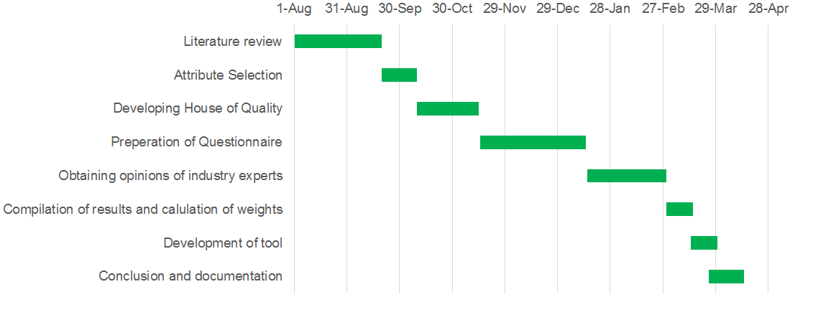

**Figure**: Gantt chart showing the timeline of the project

**2 Literature review**

**2.1 Introduction to Logistics**

Logistics is a diverse and dynamic function that is flexible and changes according to the various constraints and demands imposed upon it. There is, realistically, no precise name or definition that can be universally applied because products, organisations and systems differ. Many terms are therefore used interchangeably, in literature and in the humanitarian world. One quite frequently accepted view in the humanitarian sector is:

Logistics = Supply + Materials Management + Distribution.

Logistics is concerned with physical material and information flows from raw material through to the final destination of the finished product. Major emphasis is now placed on the importance of information as well as physical flows, and an additional and very relevant factor is that of reverse logistics – the flow of products and packaging back through the system.

## **2.1.1 How Logistics Can Help Improve Efficiency and Reduce Costs**

As the global economy moved into the 21st Century, logistics became a critical part of supply chain management and consumer demand. In less than two decades, logistics management has influenced product movement to meet or exceed consumer demand. Companies saw they could lower costs and increase productivity by managing logistics on a system theory and managing the company as a whole to boost performance.

By creating partnerships with suppliers, shipping services and warehouses, and connecting these services through automated systems, the logistics of getting products to the consumer are improved with reduced overhead costs and faster delivery. Understanding how the logistics system theory works requires strategic planning when calculating what will be needed, while focusing on obtaining materials and managing how quickly products are produced to help ensure swift delivery to the consumer.

Simplifying communication and services between multiple departments helps create a workflow blueprint that reduces costs by increasing visibility and improving the overall understanding of company needs. Cost savings is created by reducing warehousing costs and purchasing based on supply forecasts, better inventory management, reliable shipping and timely delivery to the end-user.

**2.1.2 Outsourcing of logistics services**

Many organizations delegate the execution of logistics functions to a logistics operator, in order to focus on their core competency and to increase their competitiveness while improving their operational processes, since the core competency of those operators is logistics management itself. As described by many authors, logistics operators can perform logistics services in a better, faster and cheaper manner, which is interesting to many companies.

An interesting point of view is presented by Lu and Su (2002). According to their work 1PL is a small company that executes its own logistics; 2PL is a provider of simple services, such as storage or transportation; 3PL is a logistics operator that offers a whole range of services and management. Its natural evolution is 4PL, which is the single connection between a customer and the logistics operators, being responsible for hiring other 3PL and 2PL, and managing the logistics process end-to-end.

The functions and roles of these logistics providers are explained in detail as follows:

* **1 PL (First Party Logistics):** Concern beneficial cargo owners which can be the shipper or the consignee. They dictates the origin and destination of cargo with distribution being an entirely internal process assumed by the firm. With globalisation and the related outsourcing and offshoring of manufacturing, distribution services that used to be assumed internally tend be contracted to external service providers.
* **2 PL (Second Party Logistics):** Concern the carriers that are providing a transport service over a specific segment of a transport chain. It could involve a maritime shipping company, a rail operator or trucking company that are hired to haul cargo from an origin to a destination.
* **3 PL (Third Party Logistics):** Outsourcing all of a company's logistics operations to a specialised company. Contracts for transportation had featured only two parties, the shipper and the carrier. Preferably, these services are integrated or "bundled", together by the provider. Service they provide are transportation, warehousing, cross-docking, inventory management, packaging, and freight forwarding.
* **4 PL (Fourth Party Logistics)****:** It is an independent, singularly accountable, non-asset based integrator who will assemble the resources, capabilities and technology of its own organisation and together organisations, including 3PLs, to design, build and run comprehensive supply chain solutions for clients.

Figure demonstrates the levels of logistics providers and the typical services provided by each.

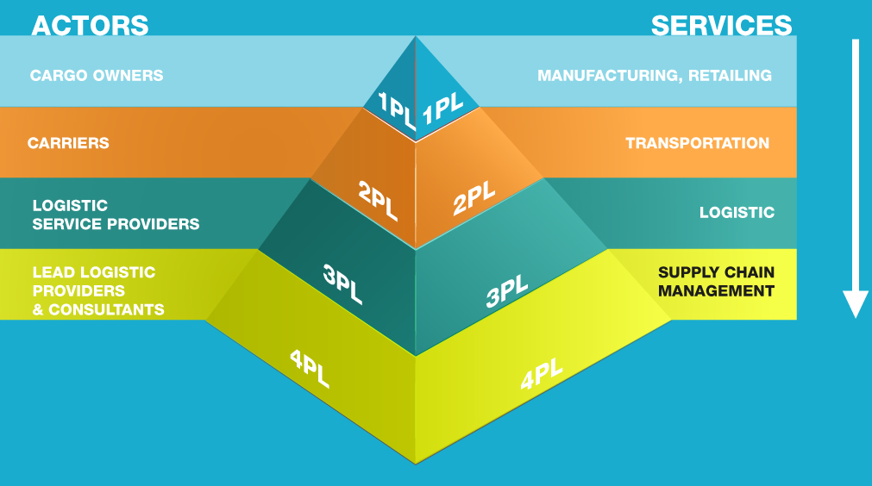

**Figure:** Levels of logistics providers

**2.2 Introduction to 4 PL (Fourth Party Logistics)**

4PL is the registered trademark of Accenture Inc. and has been defined by this company as: ‘‘A supply chain integrator who assembles and manages the resources, capabilities, and technology of its own organization with those of complementary service providers to deliver a comprehensive supply chain solution’’

In other words, 4PLs manage and direct the activities of multiple 3PLs, serving as an

Integrator. Figure demonstrates the evolution of outsourcing in logistics and the movement of the industry towards fourth party logistics.

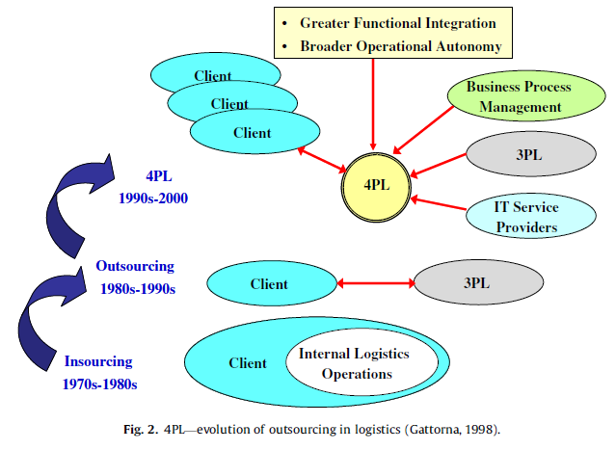

**Figure:** Evolution of outsourcing in logistics

**2.3 E-commerce logistics**

E-commerce logistics is the concept of adapting existing supply chain methods and processes to fit the e-commerce business which in several aspects differs from traditional logistics processes in terms of refining and optimizing the sequences that's included in the processes, from system integration to distribution and KPI's.

Online retail and shopping has seen a significant growth over the last decade and is expected to grow even further for the years to come. More and more traditional retailers invest in an online platform where the online sales accounts for an increasing share of the total sales volumes, and is increasingly becoming more important as it constitutes for a larger share of the total revenue stream.

As competition goes tougher, the margins are decreasing each day to merchants as they constantly need to provide their clients with unique competitive advantages which affect their profits, resulting in small margins. This emphasises the need to refine their processes further to keep up with the competition. This is one of the reasons why an e-commerce logistics service provider sees the rapid development that is going on in the business and the fact that more and more small and midrange merchants choose to outsource their logistics to gain a competitive edge.

Within the -commerce segment there are a number of specific issues to address and for the logistics service provider (LSP) to take in consideration when developing the future solutions of e-commerce logistics. Below follows some examples.

* **Collect-in-store:** The LSP need to support multi-channel distribution concepts. This means that a retailer should be able to use its network of physical store as delivery spots as a complement to the traditional pick up locations. Thus there will be opportunities for the retailer to for example sell more but also to handle returns.

* **Return handling:** In order to help their clients to make it easy and comfortable for their customers to buy online he LSP need fast and cost effective procedures when it comes to handing returns. Still slow and complicated return routines are one of the major reasons for people to choose another competing online alternative or even skip online shopping.

* **Delivery on weekends:** In a physical store it is has been obvious to people that one can buy and pick up their products not only at weekdays but also on weekends. To make the online alternative more attractive the LSP need to facilitate delivery on weekends.

* **Same day delivery:** This is another logistics issue that needs to be addressed in order to make the online alternatives more attractive compared to the physical store. Sometimes it´s urgent and the customer need their products later the same day. Thus local same day delivery has to be an option for the clients of a LSP in the future.

Thus, selection process of a suitable logistics supplier is essential to address the specific problems faced by different e-commerce companies.

**2.4 What is Quality Function Deployment (QFD)?**

QFD is a system with the aim of translating and planning the “voice of the customer” into the quality characteristics of products, processes and services in order to reach customer satisfaction. QFD is not only a quality tool, but also an important planning tool. It allows the consideration of the "voice of the customer" along the service development path to market entry.

The QFD technique is based on the analysis of the clients’ requirements, which normally are expressed in qualitative terms, such as: “easy to use”, “safe”, “comfortable” or “luxurious”. In order to develop a service it is necessary to “translate” these fuzzy requirements into quantitative service design requirements; QFD makes this translation possible.

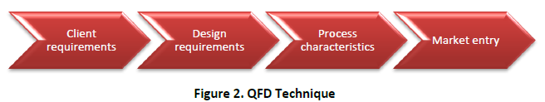

**Figure:** QFD technique

Services are not developed as a whole; instead, these are developed through the integration of different components. The component features are what provide the functionality that in turn satisfy client requirements.

The QFD methodology is based on the development of a series of matrices called “House of Quality”.

**2.4.1 House of Quality**

This matrix is called House of Quality due to a roof-like structure in its top. This house can be divided in “rooms”. A tour through the different “rooms” is given below.

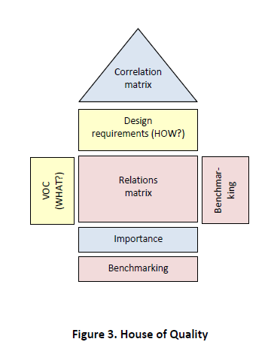

**Figure:** House of Quality

**2.4.2 Voice of the Customer (VOC)**

QFD starts with the establishment of objectives, which represent the answer to “What?”. What is desired in order to reach the new service’s development? These objectives derive from clients’ requirements and are called the “Voice of the Customer”.

**Table:** “What?” List

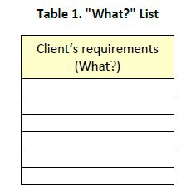

Sometimes the client requirements are general, vague and difficult to implement directly; a more detailed description is needed. There are three kinds of service characteristics that must be differentiated. The requirements mentioned directly by the clients will be called “performance requirements”; other wants are difficult for clients to verbalize. These “wants” are essential parts of the service and perform basic functions that the user expects and considers as given. These basic functions are known as “basic requirements”. The third kind of service feature is an “emotional requirement”, it reflects a need that the client has not appreciated before. Performance, basic and emotional are the three kinds of quality and are shown in the “Kano Model”.

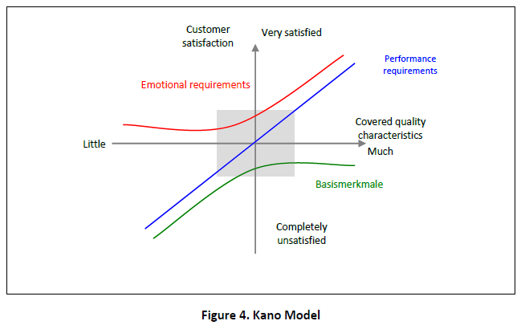

**Figure:** Kano Model

**2.4.3 Design requirements**

After completing the client’s requirements list (What?), comes the definition of “How”. The “how” are the design requirements of the service; it is necessary to define how each client’s requirement will be satisfied by the service. These are measurable features that can be evaluated at the end of the development process.

**Table:** “How?” List

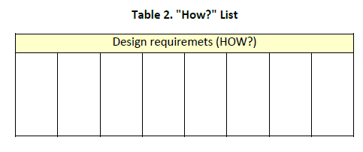

**2.4.4 Relation matrix**

Relations between the client and design requirements are not always 1:1, there are complex relationships and varying levels of strength. A single design requirement may have an influence on several of the client’s requirements. Illustrated in table 3 is a matrix that shows the relationships between “What” and “How”; defined by three strength levels: weak relation, medium relation and strong relation.

**Table:** Relationship Matrix

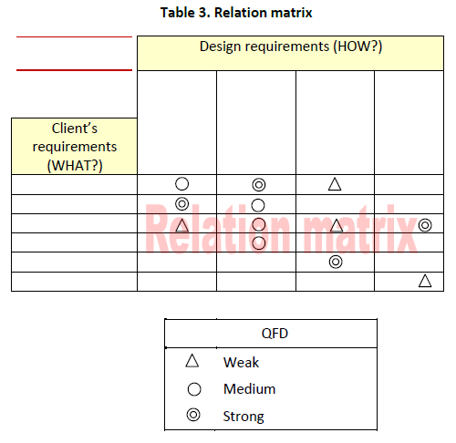

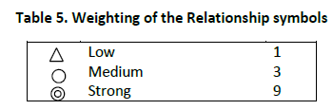

**Figure:** Weighting of relationship symbols

An empty column indicates no relationship between the client and design requirements. This may reveal that the translation from “What” into “How” was not properly conducted.

**2.4.5 Importance level**

The importance level states the relative significance of each client (“What”) and design requirement (“How”) to achieve the desired goal. “What”-s relative significance is established through an evaluation by the customer.

For each column (“How”), the (“What”) importance level is multiplied by the corresponding weighting. This creates a value for each relationship between client and design requirement. The importance of the design requirements (“How”) is computed by adding the values together.

The importance level of “How” approximates the most important design requirements for client satisfaction.

**2.4.6 Correlation matrix**

The correlation matrix is a triangular table. “How” is integrated by establishing the correlation between all of the elements. The matrix describes the strength of the relationships between the design requirements. The aim is to identify which requirements support each other and which ones do not.

**2.5 What is User’s Preference Rating?**

Acceptable level of quality is defined by multiple Quality Characteristics (QCs). Thus, multi-criteria optimization is used to obtain the best setting of these parameters. The subsequent section presents a brief account of existing multi-criteria optimization techniques.

The multi-criteria optimization methods have been classified into three types. These methods are with the following:

1. A priori articulation of preferences – where the user specifies the degree of relative importance between different objectives.

2. A posteriori articulation of preferences – where preference is given to a single solution obtained from a set of mathematical solutions.

3. Progressive articulation of preferences – where the user may not be able to clearly specify the preferences.

A good number of multi-criteria optimization techniques come under these categories, each having their own advantages and limitations. Some of the techniques can be quite simple but do not provide much information. Others are quite complex, require extensive computation but are informative.

In order to optimize these QCs, preferences are specified generally by facilitating the use of a priori articulation of preference methods. The most commonly used multi-criteria optimization technique that comes under this category is the weighted summation technique. Although weighted summation is easy to apply, it has certain limitations in comparison to other techniques. First, it could not be used in cases where the criteria transformation is non-linear. Second, the decision regarding calculation of weights has been an important issue as the final outcome depends upon it. The evenly distributed weights may lead to uneven results. A good number of techniques are available for calculation of weights. But the application of these techniques becomes complex due to rigorous calculations involved. Thus, for the sake of simplification, constant numbers are generally selected as weights. However, such constant numbers or prior selection of weights may lead to biased results of optimization. The earliest technique developed for calculation of weights is known as analytic hierarchy process (AHP). The disadvantage of this technique was the inability to handle the uncertainty decisions. Similar to the AHP process, the analytic network process (ANP) involved extensive pairwise comparisons, making it time-consuming. To extend the scale rating for comparison of attributes, the fuzzy versions of AHP and ANP were introduced. These fuzzy systems provided a wider scale for pairwise comparison; however, their use increased complexity.

Considering the limitations of all the existing techniques discussed above, a new method for calculation of the weights has been used. This technique may be called a ‘User’s preference rating’ method for optimization. The main advantage of this method is in using incomplete information that is converted into quantitative data for calculation of the weights. Also, this method is simple and requires less processing calculations.

In this method of optimization, any number of QCs and preference viewpoints of different users can be taken into consideration according to the requirement. Before the selection of weights, the voice of the user is to be conquered into a mathematical form. For this purpose, the incomplete perceptions of human beings have also been represented by graph theory technique known as ‘preference graphs (PGs)’. PGs explain the different viewpoints of users in the form of a schematic representation.

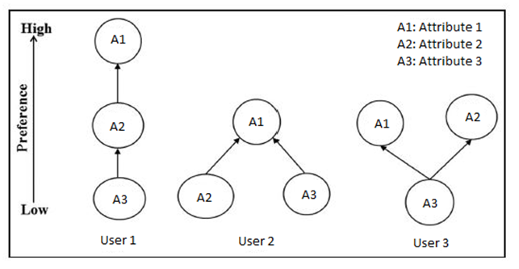

**Figure:** Example of Preference Graphs for three users and three attributes

**3 Methodology**

The process for development of the 4 PL supplier selection tool involved the construction of House of Quality followed by ranking of suppliers based on different criteria. The first step was to identify the VOCs (WHATs) that are required by the e-commerce industry. This was followed by the identification of assessment criteria (HOWs) for the 4 PL suppliers as available in literature. The next step was the calculation of weights of the VOCs and rank them in their priority order. This was followed by the formulation of the Relationship Matrix to identify the relationship between the WHATs and HOWs. Alongside, the Correlationship Matrix was developed in order to determine the relationship between the assessment parameters. The importance rating of the assessment parameters was then calculated with the help of the relationship matrix. This forms the basic framework of the tool wherein the e-commerce companies or the users are required to assess different 4 PL suppliers and rate them in terms of the given assessment criteria. The tool will then calculate the total score for each supplier and give their final ranking. The procedure followed for each of the aforementioned steps has been given in detail in the subsequent sections.

**3.1 Identification of WHATs**

There are various characteristics required of a 4 PL service provider in the e-commerce industry. After a thorough study of literature, various parameters or WHATs were identified that have been included in the following table.

**Table:** Voice of customers and their description

|  |  |
| --- | --- |
| **Voice of customer** | **Description** |
| Quality of service | Quality of logistics systems is seen as quality of service. Service provider should enhance perceived quality of customers, so as to satisfy the customers resulting in increased market share of the shipper. |
| Optimum cost | More for less through value-added services like tracing and tracking, short lead time, bundled services, etc. |
| Surge capacity | Surge capacity becomes important if (due to sudden rise in demand of product) there is a rise in the logistics needs of the shipper. It is also considered as the shippers’ exceeding logistics requirements in addition to the agreed one. |
| Delivery punctuality | Ability to deliver the orders on time, meeting deadlines. |
| Provision of emergency service | Ability to respond to emergency situations and handle them properly |
| Regularity | The dispersion around the mean value of the delivered lead-time |
| Completeness | Capability to deliver full orders when required |
| Correctness | Avoidance of mistakes in orders delivered |
| Harmfulness | Avoidance of damages in orders delivered (Proper Packaging) |
| Responsiveness | Willingness to help customers and provide prompt service |
| Productivity | Number of items/orders/ codes/quantity delivered in a given period of time |
| Designing a Supply Chain | A 4PL provider must be able to design a customized and a streamline supply chain for its client |
| Supply chain Execution and Monitoring | A provider should be able to implement, manage and control the supply chain of its client |
| Leading-edge information systems | All the information should be accessible by both the customers (firm and end consumer). Real Time Information Sharing |
| Streamlining solution of Supply Chain Managements | Capable of making competent plans for their clients’ cross-operational and value added chains (Supply Chain Planning). |
| Should provide a customer support helpline | Customers at both ends should be able to resolve their Logistics problems and issues with shipment. |
| Wide range of shipment solution for every type of shipments | Depending on how urgent is the shipment, how delicate is the shipment, etc., the 4PL provider should have a long range of solutions |
| Continuous flow of value and removal of waste in a Supply Chain | Continuous improvement of Supply chain is required |
| Knowledge of client's business | Knowledge of client’s business, products, processes, and markets |
| Ability to shift with market dynamics | As globalization continues to shape the competitive landscape, the service provider must be able to change directions as quickly as markets and individual customers do. |
| Reaching new markets | Ability to open up new markets and opportunities for the client, as quickly as the company identifies them. |
| Benchmarking processes to measure productivity | A provider should have all its operations compared against benchmarks and try to improve them to best levels |
| Create a Global Network | Service provider should help the company to realise and to reach out new markets as well as increase the reach they have in their own market, |
| Value addition to core business | Service provider should add value to the core business of the client in a way that boosts margins. |
| Reducing Logistics Cost | Reduced logistics costs and losses in inventory management of client through improved logistics asset utilization and integrated supply chain planning. |
| Risk minimization | Knowledge of the statutory requirements. Implementation of reliable processes (trade compliance) |
| Packaging | Advice on packaging type, Packaging procurement, Operational packaging / industrial packaging |
| Punctuality of Deliveries | Delivery on agreed delivery dates |
| Ability to coordinate and foster improved relationships within the value chain | The objective is twofold, both to deliver value to the organisation and also to position the organisation as a value creator within the greater value chain between point of product conception to product |
| Ability to manage supply and demand uncertainty | 4 PL's ability to manage supply demand side uncertainty and always being ready if a situation calls for deploying more resources or reducing the resources on field obviates the delay and minimises the cost involved. |
| Reputation | It refers to the opinion of the customers about how good the service provider is in satisfying the needs of the customer. |
| Information technology capability | IT capability eases up operations and increases productivity. IT capability may also lead to reduction in cost of service in the long run. |

These requirements may vary from company to company, but the salient attributes sought by the majority have been short-listed after deliberation and are included in the list below.

1. Prior experience of industry
2. Technological capability, in terms of information sharing and IT capability
3. Expansion of business, in terms of reaching new markets
4. Reduction in operational cost
5. Flexibility, provision for surge capacity for meeting uncertain market demand
6. Perceived quality, reputation of the supplier in the market
7. Customer service, service at delivery and after-sales service
8. Reduction in lead time

**3.2 Identification of HOWs**

After a careful review of supply management literature, various assessment criteria for supplier selection emerged. These criteria have been included in the following table.

**Table:** List of Technical requirements and their description

|  |  |
| --- | --- |
| **Technical Requirements** | **Description** |
| Operational performance | High operational performance improves the business relations. Clear-cut goal in terms of quantitatively measurable and meaningful performance boosts long-term relationship. |
| Financial stability | It ensures low risk relationships. Financially, sound services provider boosts customer satisfaction and reduces cost through a dedicated resource base, it also reduces logistical risks for partnering firm. |
| Demand forecasting methods | Accurate forecasting methods make it possible to match supply and demand, smoothing uncertainty, reducing safety stocks and stock outs. |
| Warehouse management optimisation | The efficiency and the effectiveness of the logistics flows are deeply affected by optimized warehouse & distribution centres management policies. |
| Just-In-Time philosophy | It helps to streamline the logistics pipeline through the efficient flow of materials and information, i.e. by providing the right materials, in the right quantities and quality, in the right place at the right time. |
| Experience of the sector | How long has been the supplier operating in a particular sector. The experience will define the maturity in actions and the extensive knowledge of the sector will make the decision making efficient. |
| Capacity for Innovation | Follow up on customers evolution in terms of changes in its strategy and market |
| Geographical Position | The geographical position is important because it determines the cost and the ease of delivery. Also it will be an important factor when the firm is launching in new markets. |
| Experience in managing global supply chains | 4PL service provider's reach and experience globally reinstates the confidence and also reduces the firm’s partners by allowing it to partner with a single firm globally thereby increasing the efficiency of operations and strengthening the relationships |
| Process Control | Value is created and rewarded as a result of consistency and reliability of product or service delivery. Consistency and reliability are the result of clearly defined and tightly managed processes. |
| Documentation | Ability to document all procedures and processes and keep track of performance |
| Compatibility | It is very important criteria as it enables the user and the provider to work together. Compatibility of culture and values is one of the keys to successful partnership which can result in long-term relationship. |
| The quality of management | It infuses innovativeness and responsiveness in the system to guarantee high service level. Quality of management also helps in strategic decision-making in order to have a long-term effect. |

A careful analysis of the above identified seven criteria crucial to 4 PL supplier assessment in case of e-commerce industry. These have been included in the list below.

1. Financial stability (FS)
2. Experience of top management (EM)
3. Geographical position (GP)
4. Self-assessment ability (SAA)
5. Quality system certification (QSC)
6. Packaging solutions (PS)
7. Order forecasting and management (OFM)

**3.3 Calculation of weights of WHATs**

The weights for the customer needs were calculated with the help of User’s Preference Rating. For this, industry experts from 5 e-commerce companies (Amazon, Flipkart, Snapdeal, Ajio and Ebay) were contacted. The responses from each company were clubbed and company-wise preference graphs were constructed. This was followed by creation of Adjacency and Dominance matrices. The relative degrees of performance for attributes were then calculated for each PG. The final rating for each attribute was calculated by combining the responses of all the users. This process has been explained in detail in the subsequent sections.

**Step 1: Creation of Preference Graphs (PGs)**

The aim of creating preference graphs is to prioritise the attributes, as preferred by each user. As mentioned earlier, the responses obtained from industry experts were compiled and responses from the same company were clubbed and company-wise PGs were constructed. The PGs for each of the 5 companies have been given in the following figures.

These representations are to be converted into a mathematical form, which involves a number of steps. These steps are given as follows.

**Step 2: Creation of Adjacency Matrix**

The adjacency matrix is used to represent the relationship of an individual’s PG in a matrix form. One number represents a relationship between the QCs. A general adjacency matrix can be represented as

**Step 3: Creation of Dominance Matrix**

**Step 4: Calculation of Relative Degree of Performance**

**Step 5: Calculation of Relative Importance Rating**

**Step 6: Calculation of weights**

**3.4 Development of Correlationship Matrix**

The correlations between the supplier assessment criteria (HOWs) are contained in the ‘‘roof’’ of the HOQ (Figure). This step in the construction of the HOQ enables the team members to keep track of pairs of ‘‘HOWs’’ needing parallel improvements and/or comprising ‘‘HOWs’’ in potentially difficult relationships that consequently imply measures that are inconsistent with each other. This matrix contains positive and negative correlations between pairs of ‘‘HOWs’’ using symbols that are given in Figure.

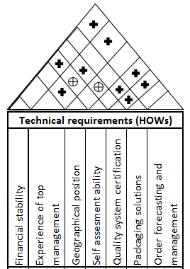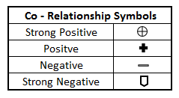

**3.5 Development of Relationship Matrix and Calculation of Importance Rating**

For determining the “HOW”- “WHAT” correlation scores in the Relationship Matrix, we brainstormed over the parameters along with our faculty advisor and assigned weights to the relationship between the customer requirements and the technical descriptors. Weights of 1, 3 and 9 were assigned to low, medium and strong relationships respectively. These have been included in Figure.

The Importance Rating for HOWs was calculated using the following equation:

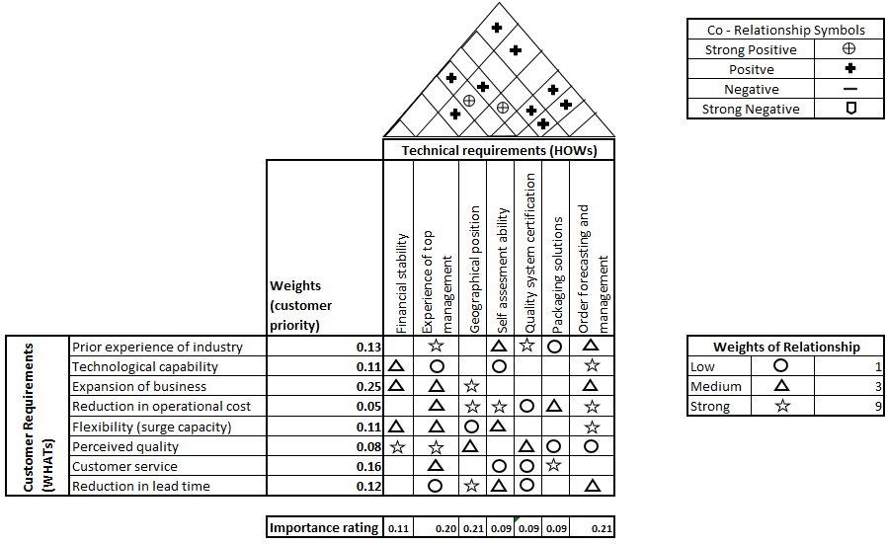

**3.6 Suppliers ranking Guidelines with a numerical example**

The last step in the procedure is the supplier selection. This step has to be carried out by the e-commerce company with an objective to select the best supplier according to its needs. The guidelines for selecting a supplier to be followed by the company are explained with the help of an example.

**Numerical Example**

An e-commerce company A is desired to select a 4PL supplier for operation in a market that it has recently entered. Three suppliers have shown interest. We will denote the three suppliers as S1, S2 and S3 respectively. The company now has to evaluate the suppliers based on their assessment criteria and rank them in decreasing order of preference.

Procedure to rank the suppliers is as given below:

**Step 1**: Determine the weights for each technical capability for each supplier

Each supplier is given ratings for each of the seven assessment criterias

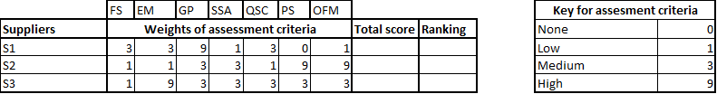

**Step 2:** Calculation of the total score.

A total score for each supplier is calculated with the help of the following formula.

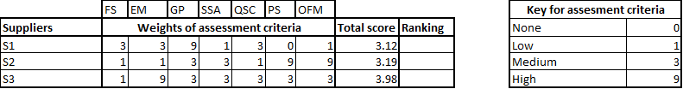

**Step 3:**Ranking of the supplier

Suppliers are ranked in decreasing order of their total score. Supplier with the highest total score is selected as a partner, Supplier 3, in this case.

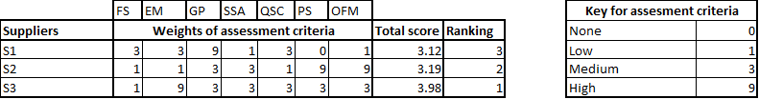

**Discussion & Future**

The approach proposed in this project is based on the distinction between the attributes of the product/service being purchased from outside the company and the

intrinsic attributes of the suppliers. It becomes evident, in fact, that the company’s ultimate aim is to have access to supplies that ensure a certain quality standard, in terms of the characteristics of the purchased products or services, and as regards efficient deliveries. It is equally clear, however, that achieving these objectives depends largely on the characteristics of the supplier himself. It becomes impossible, or at least conceptually unwise, to attempt to achieve such objectives by restricting the assessment to only one of these two categories of attributes. Constructing an HOQ enables these two groups of attributes to be correlated so that we can pinpoint how well each supplier characteristic succeeds in meeting the requirements established

for the product being purchased outside the company; having done so, we can go on to draw up a supplier ranking list.

The proposed method should be used with following 3 objectives

1. Arrive at best possible assessment parameters
2. Narrowing down the supplier pool to a select few
3. Selecting the best possible supplier depending on company’s needs

One factor that can be worked upon into the future and induced in this model is Credibility. Take for examples – Merchant Banks. Banks compile all the data of their customers and share it with other banks to calculate credit-worthiness of any individual which further helps them to minimize risk of negative loans or defaults. In a similar fashion, the e-commerce company can gather the data on the 4PL suppliers and consider modeling their credibility so that the leading and efficient 4PL suppliers can be identified and further rewarded with more orders and easy finances.

Benchmarking can be done once the model is executed. It can be worked upon where this model needs to improve when compared to results of other models.

**Conclusion**

**References**

1. Liliana Carbone (Jul 20, 2015) Retrieved from: URL (http://dlca.logcluster.org/display/LOG/Logistics)
2. Why Logistics is Fundamental to Supply Chain Success (no date) URL: (https://www.michiganstateuniversityonline.com/resources/supply-chain/logistics-fundamental-to-supply-chain-success/#.WOqFItKGO00)
3. < Defining and calibrating performance indicators of a 4PL in the chemical industry in Brazil >
4. <Lu, H., Su, Y., 2002. An approach towards overall supply chain efficiency. Master Thesis, School of Economics and Commercial Law, Goteborg University. >
5. <How it works out for each of Logistics parties :1PL to 4PL (Sep 3rd, 2016) URL: (https://blog.giztix.com/en/Knowledge/logistics-parties)>
6. <Evaluation of 4PL operating models: A decision making approach based on 2-additive Choquet integral>
7. <The Future of Supply Chains (Sep 3, 2013) URL: (https://community.kinaxis.com/people/dustinmattison1974/blog/2013/09/03/e-commerce-logistics) >
8. <QFD Handbook>
9. <AD sir paper>

“New rating methods to prioritize customer requirements in QFD with incomplete customer preferences” by Yoon-Eui Nahm & Haruo Ishikawa & Masato Inoue.